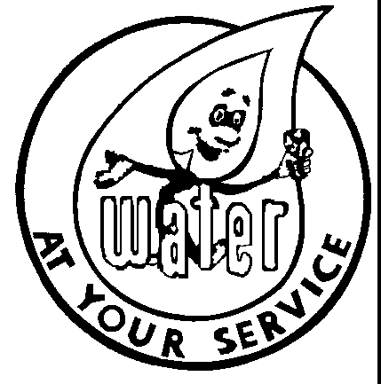

Water Board Meeting
Tuesday, May 14, 2024
3:30 p.m.
City Hall in the Water Office

A Water Board meeting will be held at City Hall on Tuesday,
May 14, 2024, at 3:30 p.m.

- Approve April 16,2024 minutes.
- 86 Seneca Ave remove late fee penalty.
- Naming of the new Water Board chairperson
- Welcome Jim Chamberlain to the Water Board

