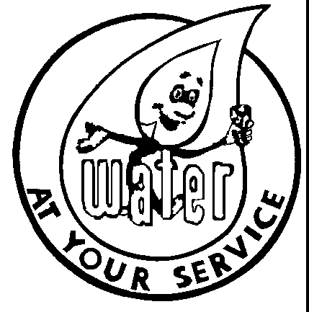

Water Board Meeting
Tuesday, April 16, 2024
3:30 p.m.
City Hall in the Water Office

A Water Board meeting will be held at City Hall on Tuesday,
April 16, 2024, at 3:30 p.m.

- Approve February 13, 2024, minutes.
- 337 Mac Arthur Parkway, leak adjustment

